Kosta Sarinopoulos

EC 499

12/13/2022

How COVID-19 stay-at-home policies has changed electricity consumption behavior?

Introduction:

The purpose for this study is to see how COVID-19 has changed electricity consumption behavior by sector (residential, commercial, industrial, and transportation). Researchers know it is important to study the energy markets because energy is needed to perform almost all economic activity which means electricity demand could serve as a real-time proxy for overall economic activity (e.g., Bui and Wolfers, 2020). Also, it is critical to plan and study energy consumption because each sector requires different types of infrastructure which is costly. One immediate effect of COVID-19 was stay-at-home government policies which caused the amount of people to work from home to triple (Census 2022). All of this begs the question, how did our energy behavior change as a result of COVID? Now that we are in more of “Post-Pandemic” I want to perform a retroactive study on electricity consumption. More specifically, my academic research sets out to answer the question: How COVID-19 stay-at-home policies has changed electricity consumption behavior?

In my research, I will be using a total of three state-month panel datasets and one state-quarter panel dataset to answer the question above. The datasets include electricity consumption, GDP, average temperature, and Oxford Stringency Index data. Oxford Stringency Index measures the overall strictness of the lockdowns through 22 metrics such as school closures, travel restrictions, vaccine policies, etc.

The methodology used throughout my research is a multiple OLS with time and state as fixed effects. More so, I ran multiple regressions with each type of sectors energy consumption as the output variable and Stringency Levels as a predictor variable with temperature and GDP as controls. I used these controls because outside temperature indicates how much buildings need to be heated/cooled and GDP is a measure of economic activity. To clarify, I used the absolute difference in temperature from 65-degree Fahrenheit as that is when people switch from heating to cooling (Brewer 2021). These controls resulted in statistically significant a majority of the time which indicates the variables are strong controls. To improve these regressions, I added layers of fixed effects including yearly, quarterly, and state based.

Through simple exploration of the data, I find that there was an immediate and drastic effect of COVID-19 to the energy markets. In fact, there was an increase of 2% in residential energy consumption which is a significant 9,000,000 MWh which is enough power for around 4.5 million homes! Upon further analysis with the OLS models, I find that there is a relationship between stringency levels and energy consumption. As expected, there is a positive relationship between residential consumption and stringency, and a negative relationship between industrial/commercial consumption and stringency. I did not find these relationships to be statistically significant when there were quarterly and state fixed effects indicating the relationship not to be causal. However, when the regression only includes state fixed effects there is a statistically significant relationship.

Currently, there are several economic papers touching the effect COVID had on electricity consumption. I have cited 3 in my bibliography that use various approached including DiD, matching algorithms and cluster analysis. What my paper contributes to the overall literature on this topic is it adds more time to retroactive study, and I specifically look at stringency levels and its effect on energy consumptions

Data Description/Summary Stats:

1. State-Month panel dataset of electric consumption segmented by sector (Residential, Commercial, Industrial, Transportation)
   * Source: US Energy Information Administration
2. State-Quarter panel dataset of GDP
   * Source: St. Louis FRED
3. State-Month panel dataset Oxford Stringency Index (Measurement of Strict Lock-down levels where)
   * Source: Our World in Data and University of Oxford
4. State-Month panel dataset of monthly average temperature
   * Source: National Center for Environmental Information

Above is a summary statistics table of the aggregate dataset. There are a total of 1920 observations (10 quarters\*48 states \* 4 sectors). GDP is in millions of dollars, Revenue is in thousands of dollars, Sales is in MWh, and Energy Price is in ¢/kWh.

\*Note *Sales* indicated total energy consumption.

Above is a graph of stringency levels per state compared to the US Average. The states were chosen randomly, and the data indicates some states like California and Michigan were stricter than average, and some states like North Dakota and Iowa were much less strict.

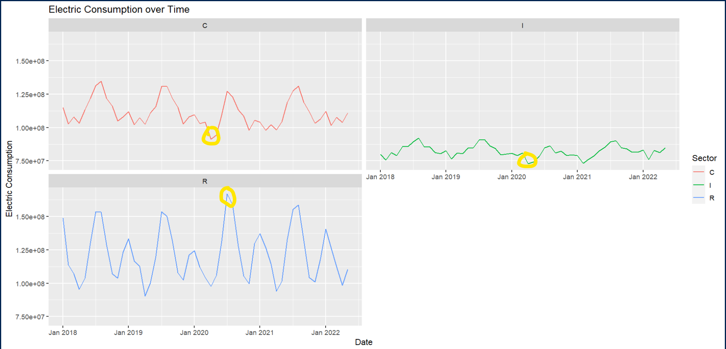

Above are graphs showing electric consumption over time segmented by each sector. We see that for residential that the peak in 2020 is much larger than previous years. Also, there are immediate downward spikes in usage for commercial and industrial.

\*Note that electric consumption level follows an oscillating pattern with peak usage in the summer and troughs in the winter.

Empirical Specification:

Ys,q,r = β0 + β1|Ts,q,r -65|+ β2(GDPs,q,r) + β3(Stringencys,q,r) + λs + θq + ε

S = state

Q = quarterly

R = Sector (Residential or Commercial)

λ = State Fixed Effects

θ = Time-Based Fixed Effects

Regressions Results and Interpretation:

For all the below regressions tables note that (1) is Residential Consumption (2) is Commercial Consumption (3) is Industrial Consumption (4) is Transportation Consumption.

Above includes quarterly and state fixed effects, stringency is not statistically significant for any of the sectors. This indicates that there is not a causal relationship. There is a positive beta coefficient for residential and transportation sectors. There is a negative beta for commercial and industrial sectors. We do see signifcance in our controls (temperature and GDP).

Above contains state and yearly fixed effects. We see statistically significant (5% level) negative relationships between stringency and consumption for commercial, industrial, and transportation). There is also a positive insignficant relationship between residential consumption and stringency.

Above contains state fixed effects only. There is a signicant (10% level) positive relationship between residential consumption and stringency. Also, there is a signicant (1% and 10% level respectively) negative relationship between industrial and transportationconsumption and stringency.

Overall, my findings concur with previous literature in that residential consumptions increase after the pandemic as well as commercial energy use decreasing.

Weaknesses

There are some weaknesses present in this paper. Firstly, there is no perfect measure on the level of lockdowns, but for the purposes of the research I used an index. Also, using quarterly data caused some data loss. Overall, I did not find causality in the research so maybe approaching this a Diff-in-Diff approach could produce these results.

Conclusion

This paper investigates how government stay-at-home policies affected the energy consumption in the United States. My research indicated that stay-at-home policies changed our electric consumption behavior so that residential consumption increased and industrial/commercial decreased. Although, my paper does not prove causality between consumption and stringency, my research did indicate a strong relationship. Causality could possibly be found through a more complex Diff-in-Diff analysis. Overall, the results prove that governments policies can be effective in changing in behavior. One possible application of this is in the event of an emergency shortage in the energy supply, then government could effectively change behavior. Finally, the government can use these results to better plan our costly energy infrastructure.

Bibliography

Brewer, Dylan. “Changes in Electricity Use Following COVID-19 Stay-at-Home Behavior.” *National Bureau of Economic Research*.

Buechler, Elizabeth. “Power and the Pandemic: Exploring Global Changes in Electricity Demand During COVID-19.” *Precourt Institute for Energy of Stanford University*.

Bui, Quoctrung, and Justin Wolfers. “Another Way to See the Recession: Power Usage Is Way Down.” *The New York Times*, The New York Times, 8 Apr. 2020, https://www.nytimes.com/interactive/2020/04/08/upshot/electricity-usage-predict-coronavirus-recession.html.

Bureau, US Census. “The Number of People Primarily Working from Home Tripled between 2019 and 2021.” *Census.gov*, 16 Sept. 2022, https://www.census.gov/newsroom/press-releases/2022/people-working-from-home.html.

Cicala, Steve. “Jue: Insights: Powering Work from Home.” *Journal of Urban Economics*, 2022, p. 103474., https://doi.org/10.1016/j.jue.2022.103474.